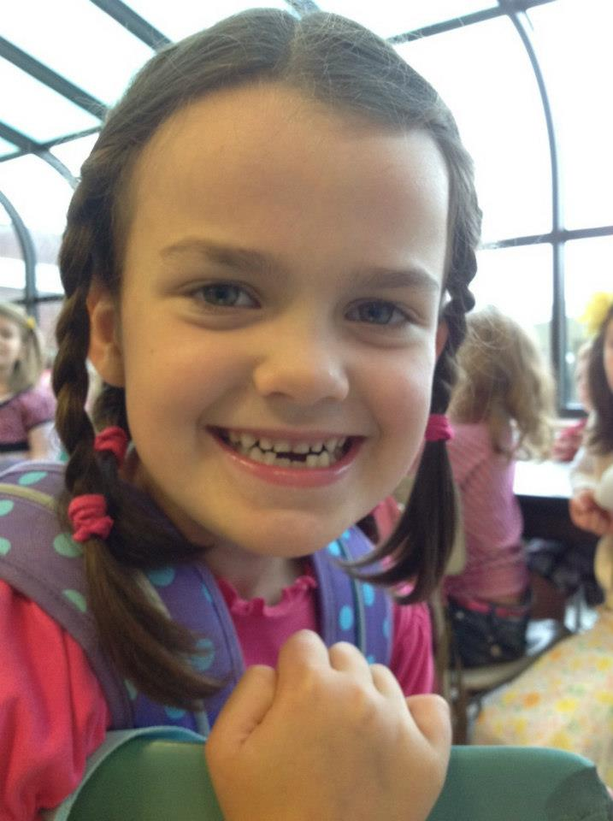
Committee on Special Education (CSE)
Unatego Central School District | Contact Us:  Special Programs Office  2641 State Highway 7  P.O. Box 483  Otego, Ny 13825  Phone: 607-988-5034  Fax: 607-988-5070
What is the CSE?
The Committee on Special Education serves students with disabilities in grades K through 12. In order to be classified by the CSE, a student must be found to have an educational disability, through the referral process described in this brochure.
I think my child needs more help. What  should I do?  First, always talk to your child’s teacher first. They can help you decide if making a referral to the CSE is the right step. There are many ways students can receive extra help without special education services, such as academic intervention services, after-school homework help, school counseling, etc.  If your child isn’t already receiving any of these, it usually makes sense to request them first. Talk to your child’s teacher or your principal. | Eligibility:  In order to qualify for special education services, a child must not only have a disability, but the disability must be significantly interfering with their education. Not all students with a disability qualify for special education services.  After the evaluations are complete, an eligibility meeting will occur. At this meeting, we discuss whether the child qualifies for special education services and what types of supports should be put into place.  Individualized Education Plan:  If a child is found eligible, a plan called an Individualized Education Plan (IEP) will be written. The plan will include special education services, as well as any needed program and/or testing modifications that are needed.  Special Education Services Include:  - Direct Consultant Teacher Services  - Indirect Consultant Teacher Services  - Resource Room  - Special Class Instruction  Related Services Include:  - Speech and Language Therapy  - Occupational Therapy  - Physical Therapy  - Counseling
Making a Referral
Teachers can complete a “Request for Referral” form. As a parent, you can also make a referral. Submit your request to the Special Programs office in writing, and include a detailed description of your concerns. Be as specific as possible!
After the Special Programs office receives a request, will send out a consent form and other paperwork describing what evaluations will be done. Parental consent must be returned before a student can be tested.
Multi-Disciplinary Evaluation
Once parental consent is returned to us, a multi-disciplinary evaluation will be conducted. Depending on the concerns involved, this may include several of the evaluations described on page 2 of this pamphlet. New York State requires that districts complete these evaluations within 60 calendar days of the date that parental consent was received.

Types of Evaluations:
Classroom Observation- An observation of the child is required for all initial CSE Evaluations. The child will be observed in their educational setting by a school psychologist, special education teacher, or other qualified professional.
Physical Examination- A physical examination is also required for all initial evaluations. Usually the school district already has a recent physical exam on file, and this is used to determine if any physical or medical factors interfere with the learning process, such as vision or hearing.
Social History- A psychologist, special education teacher, or other professional will contact you to gather background information about your child. You may be asked to complete a social history questionnaire or other paperwork about your child.
Psychoeducational Evaluation- Conducted by the school psychologist, this evaluation typically includes an examination of a child’s ability to learn, academic achievement skills, and any emotional or behavioral factors that may contribute to learning difficulties.
Speech and Language Evaluation- Conducted by a Speech and Language Pathologist, for the purpose of identification of articulation, language, and communication disorders.
Occupational Therapy Evaluation- Conducted by an Occupational Therapist. This includes an assessment of fine motor skills, oculomotor skills, visual-motor integration, strength, muscle tone, pencil grasp, etc. Emotional regulation and sensory processing are also examined when appropriate.
Physical Therapy Evaluation- Conducted by a Physical Therapist. Large muscle (gross motor) skills are evaluated, including balance, coordination, strength, visual motor control, speed, and dexterity.
Functional Behavior Assessment- An intensive process of gathering and analyzing information in order to determine the purpose or intent of a child’s behavior. This type of evaluation is usually conducted when behaviors are severe or are significantly interfering with learning.
Should I tell my child about the testing?  Tell your child that someone will be working with them a few times, and to try their best. Usually we try to avoid using the word “test,” as this can make them nervous. If they ask why this is going to happen, explain that we want to see how well they are learning in school and to find out what their teachers can do to help them learn the best way. | What else do I need to know:  These services are usually available within our school buildings, often within the same classes your child attends now. However, some students with severe disabilities attend programs through cooperative agreements with other schools
 | If a child does not qualify for special education services, they may still qualify for a Section 504 Plan. Eligibility under 504 is broader than under special education, and can include related services, testing accommodations, and program modifications. In addition, other supports are available to general education students, including school counseling, academic intervention services, after school homework help, etc.
What if I still have more questions?
A more comprehensive resource about the evaluation process and special education can be found here: www.p12.nysed.gov/specialed/publications/policy/parentguide.htm And of course, feel free to ask questions throughout any of this process. There is no such thing as a “stupid” question! Call the Special Programs Office at 607-988-5034.

